* **Create a new Lambda Function**

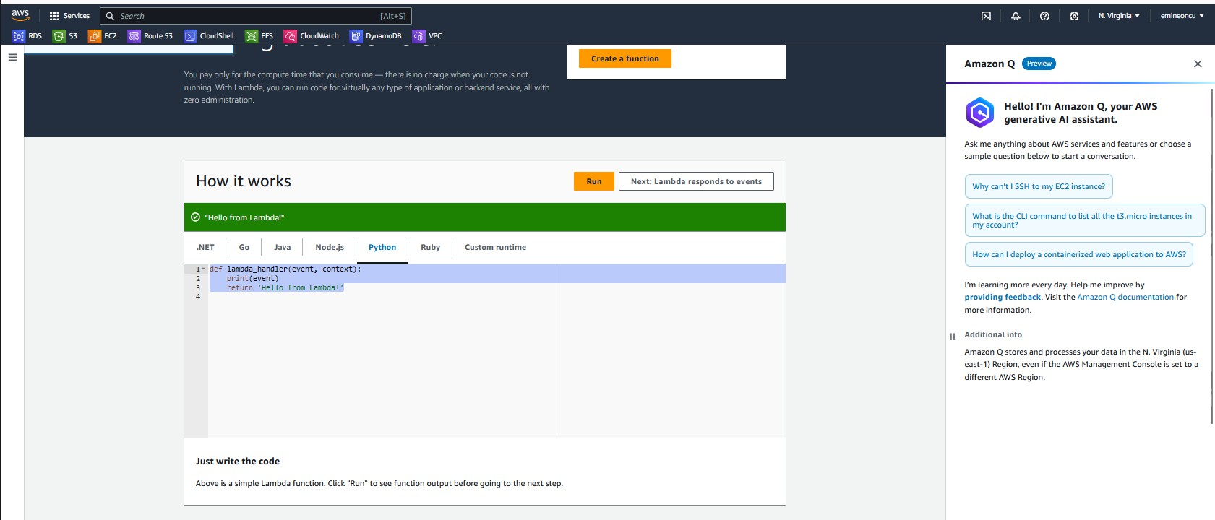

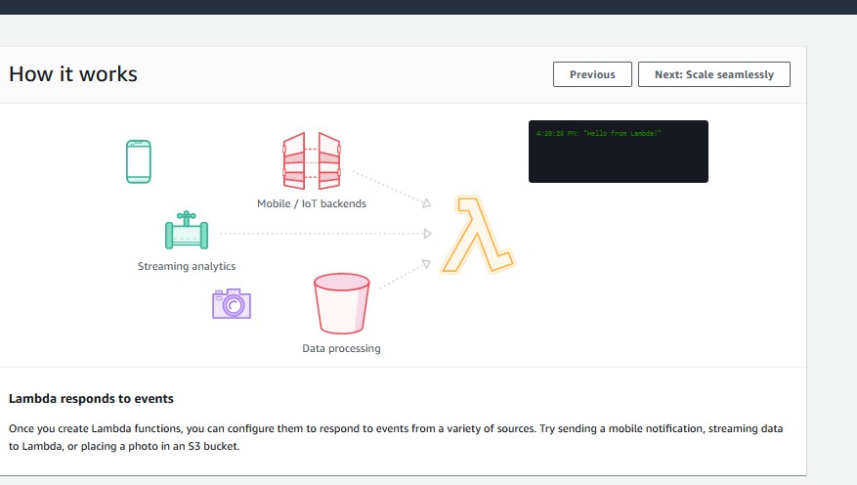

* **How it Works**

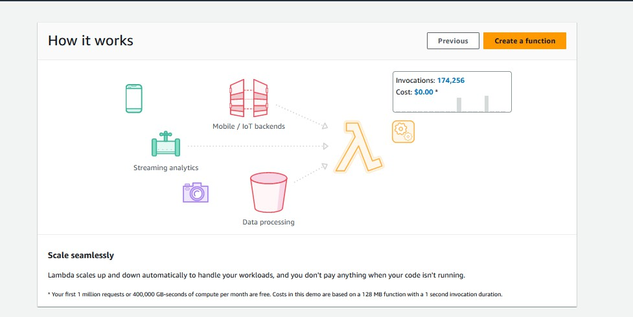

* **Lambda Function Code**

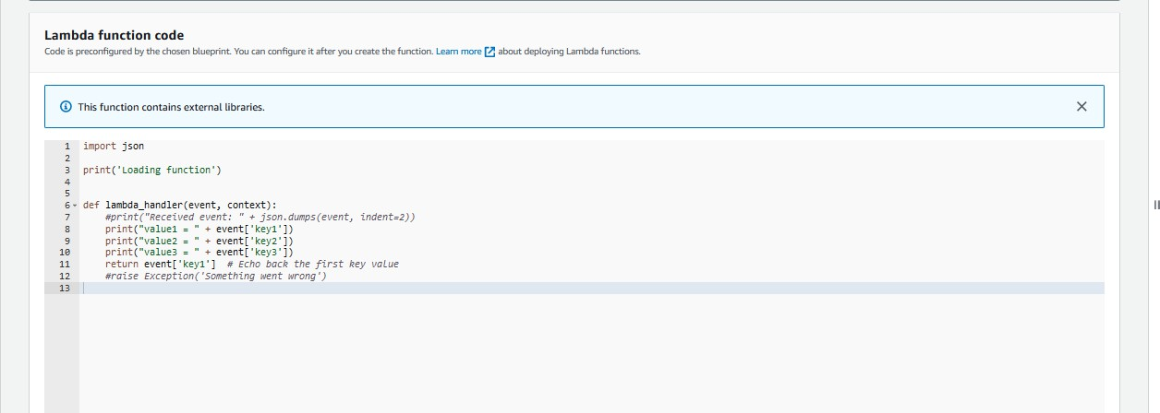

* **Lambda function created.**

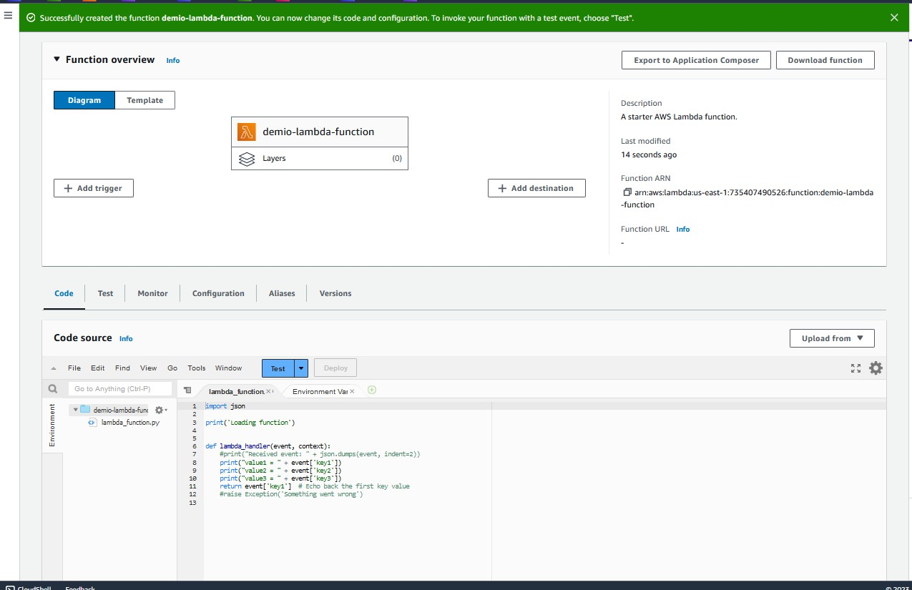

* **Configure test event.**

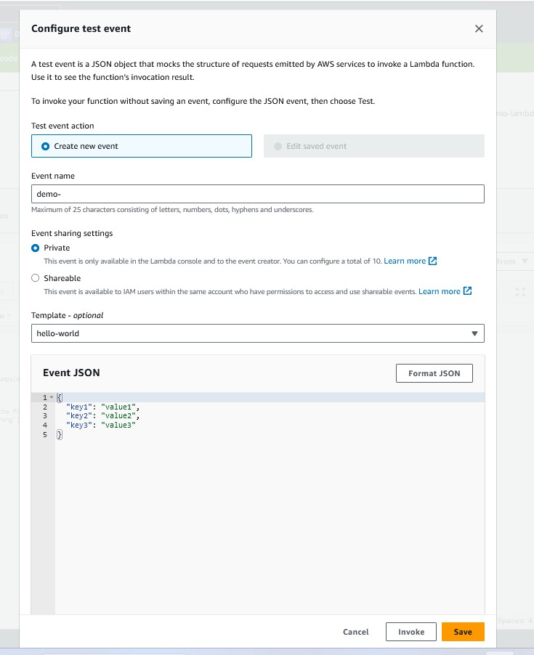

* **Code deployed and it is ready to test.**

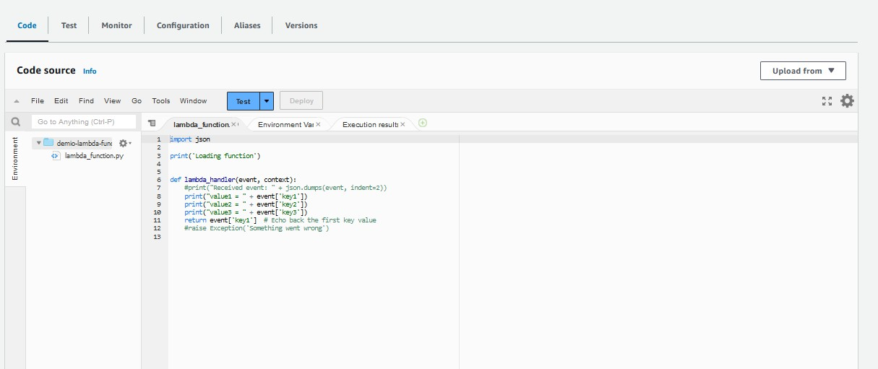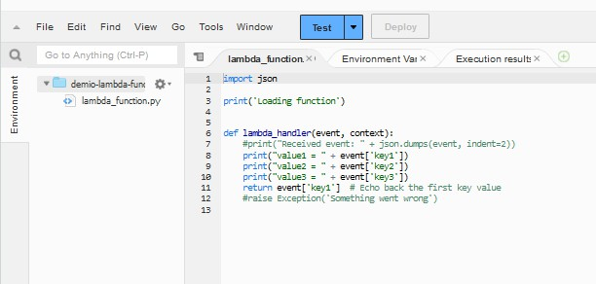

* **Test result page, Response is “value1.”**

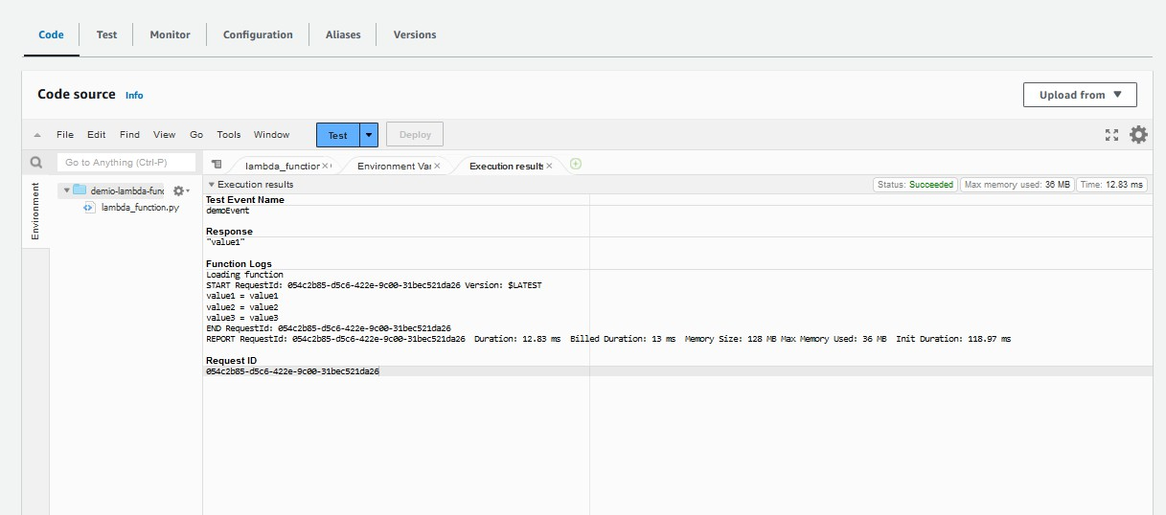

* **We can configure our Lambda function memory allocation, storage, timeout limits, execution roles with permission to upload the logs to AWS CloudWatch, etc. using the configuration options:**

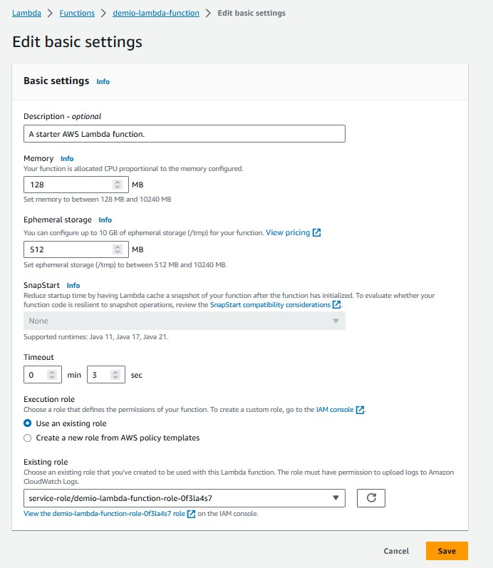

# CloudWatch logs

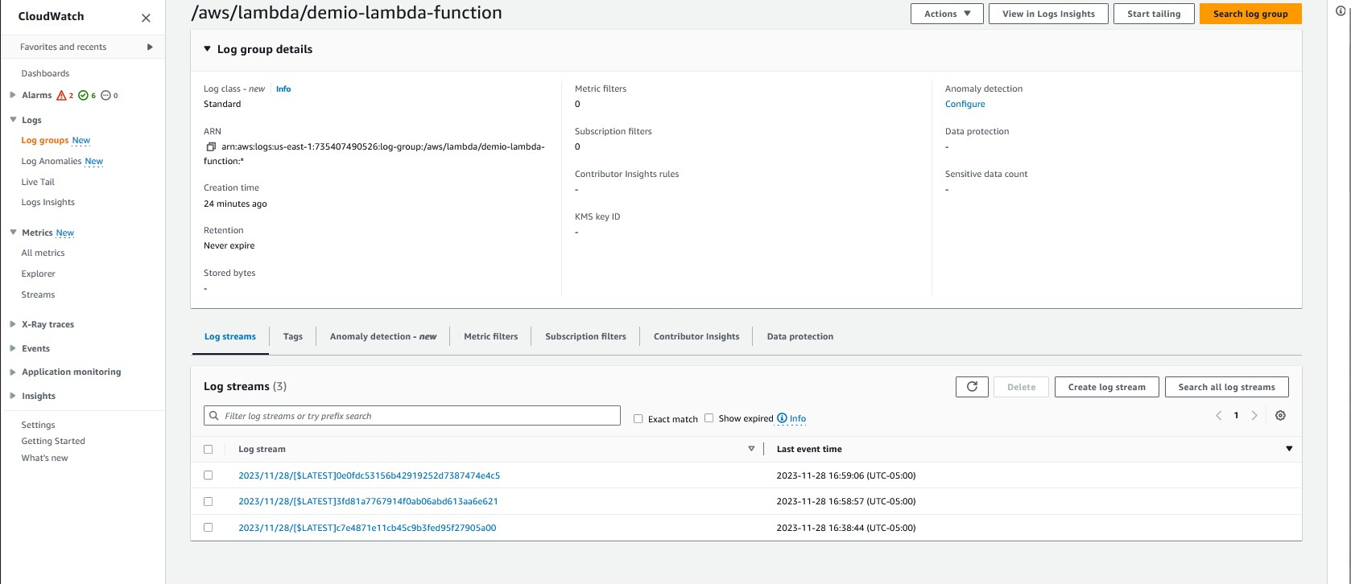

* **Invoking Lambda function will generate CloudWatch logs:**

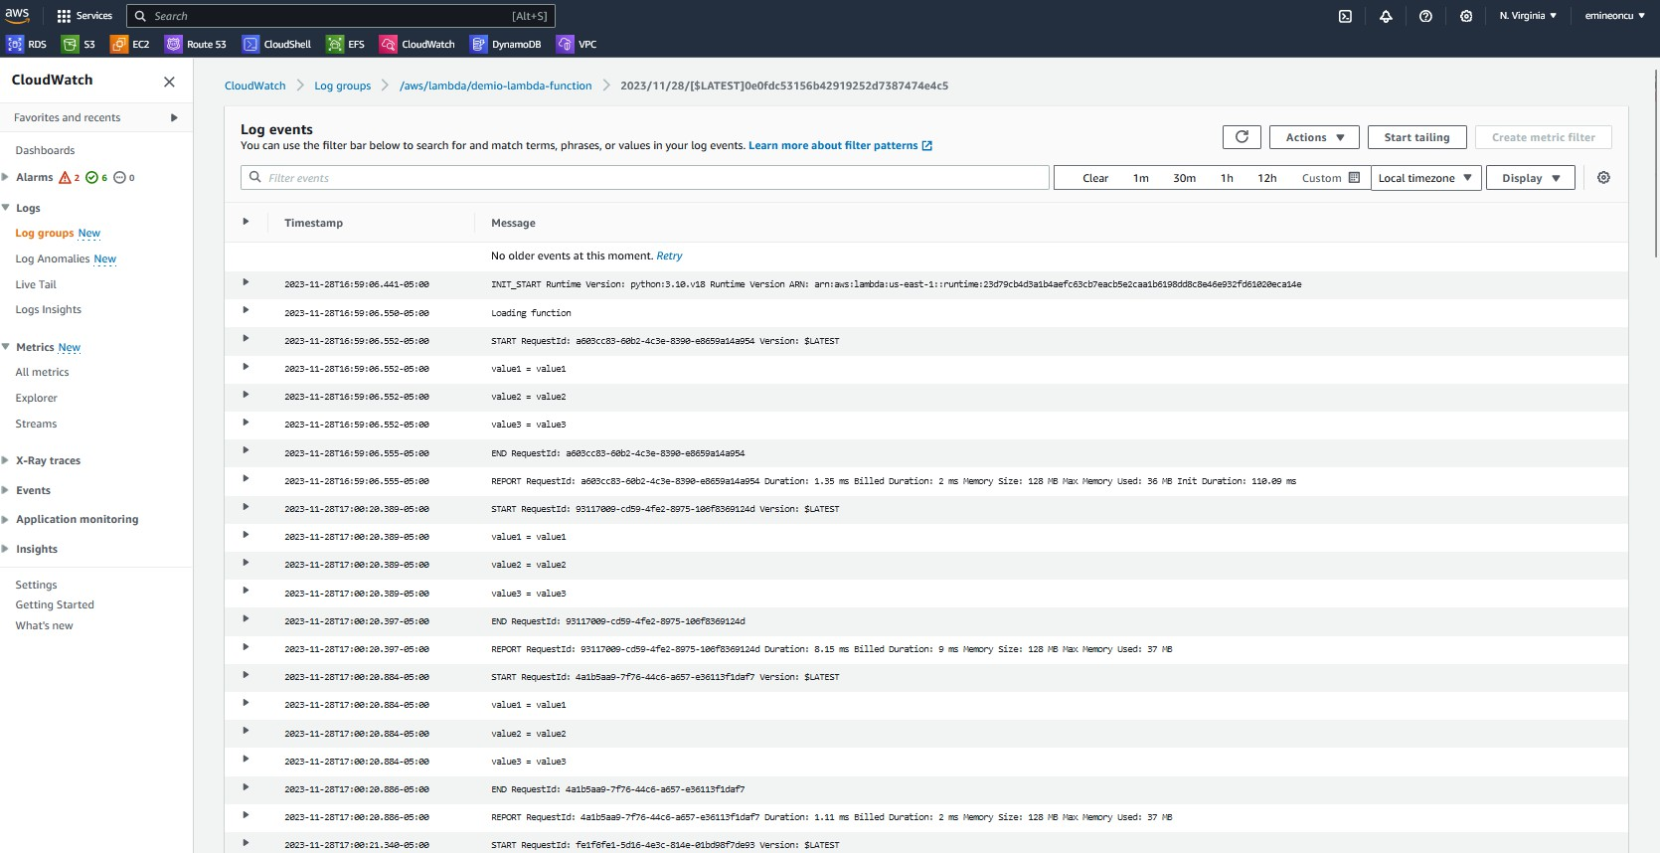

* **Permissions tab indicates that permissions given to Lambda function to write to the logs:**

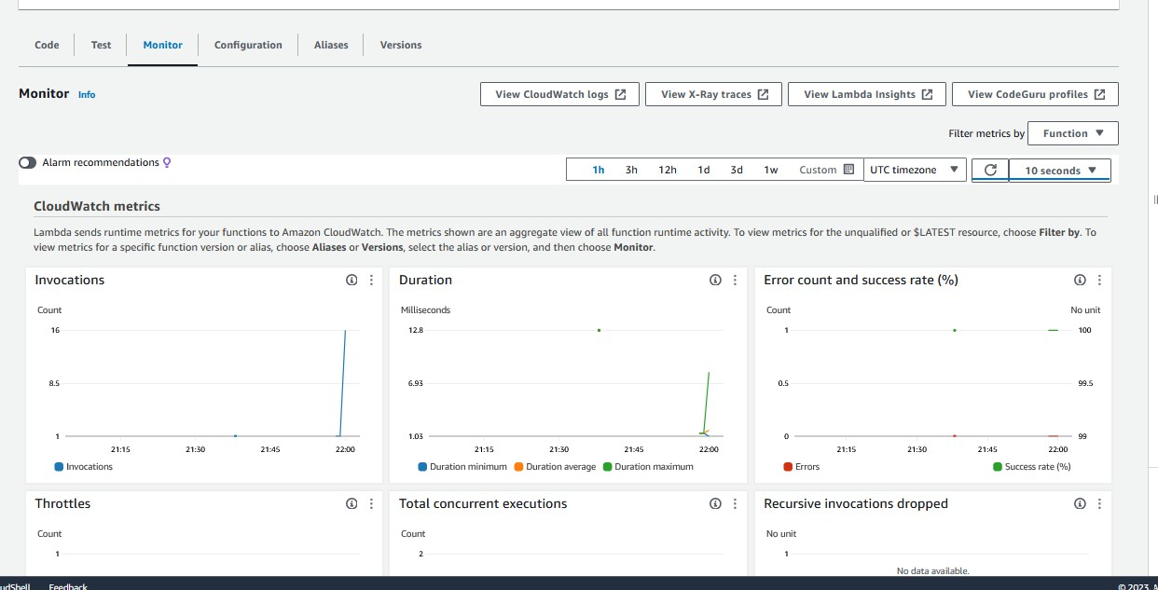

* **Permissions tab indicates that permissions given to Lambda function to write to the logs:**

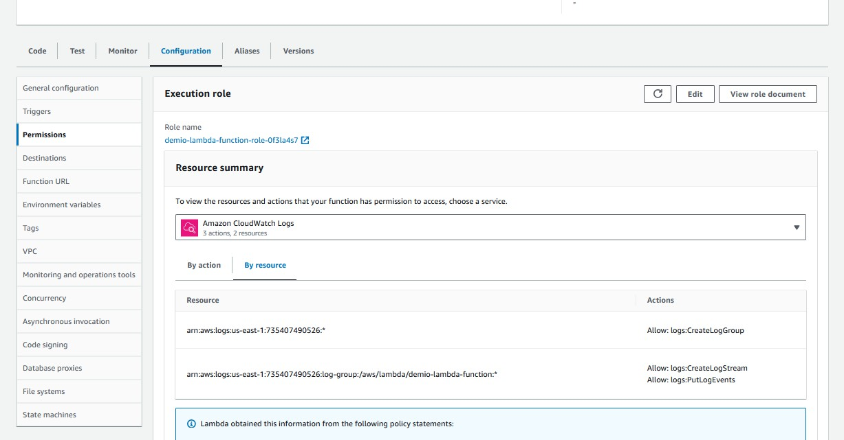

* **We can see below picture, CloudWatchLogs permission.**

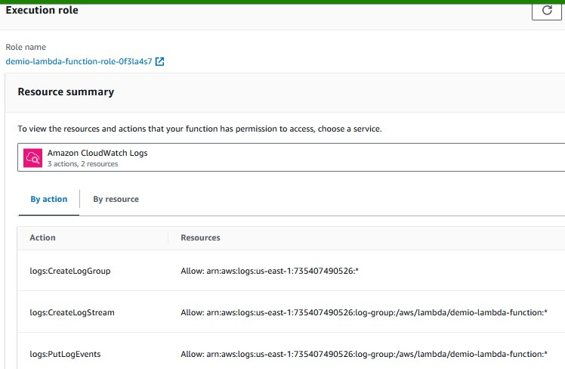

Note: I covered the 5.2 DynamoDB section in the Chapter 4 Relational Database Service RDS.